Question One
Given a list of integers, write Python code to create a new list with same number of elements

as the original list such that each integer in the new list is the sum of its neighbors and itself in

the original list.

For example, if list A = [10,20,30,40,50], then list B = [30,60,90,120,90].

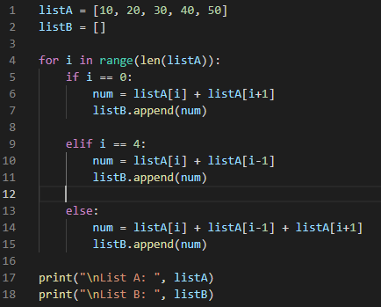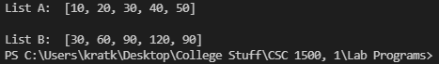

Question Two
Write a program that calculates the amount of money a person would earn over a period

of time if his or her salary is one penny the first day, two pennies the second day, and

continues to double each day. The program should ask the user for the number of days.

Display a table showing what the salary was for each day, and then show the total pay at

the end of the period. The output should be displayed in a dollar amount, not the number

of pennies.

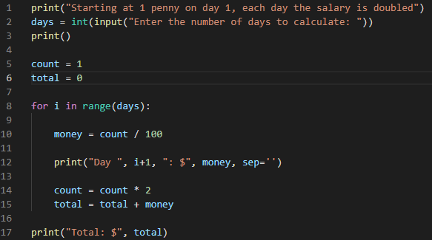
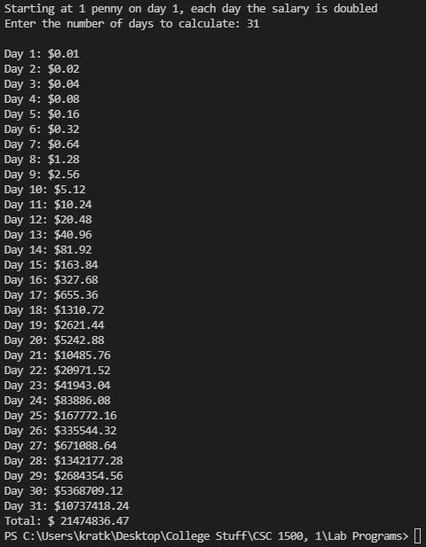

Question Three
Encryption:
Write a program in Python or C++ that has TWO functions:
Function One is called: _encrypt
Function Two is called: _decrypt
Function one takes plain text, and assesses the indexed value of each letter in the string. For example, a=1, b=2. It then adds three to the indexed value, and produces encrypted text, based off of the plain text.
Function two reverses this.
Here is sample output:
_encrypt('how do you do')
Unsecured: howdoyoudo
Secured: lsahscsyhs

_decrypt('lsahscsyhs')
Unsecured: lsahscsyhs
Secured: howdoyoudo

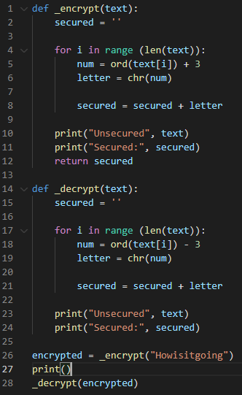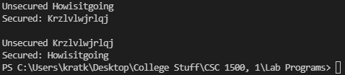

Question Four

Sum of consecutive integers

a) Write a program that prompts for an integer—let’s call it X—and then finds the

sum of X consecutive integers starting at 1. That is, if X=5, you will find the sum of

1+2+3+4+5=15.
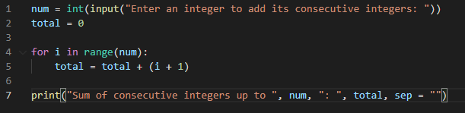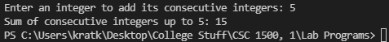

b) Modify your program by enclosing your loop in another loop so that you can find

consecutive sums. For example , if 5 is entered, you will find five sum of consecutive

numbers:

1 = 1
1+2 = 3
1+2+3 =6
1+2+3+4 =10
1+2+3+4+5 =15
Print only each sum, not the arithmetic expression.
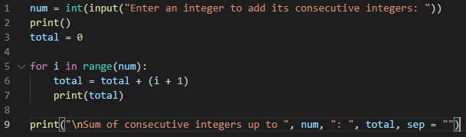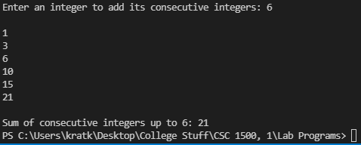

Question Five

Decision Structures and Boolean Logic

1. Write an if statement that assigns 20 to the variable y and assigns 40 to the variable z if

the variable x is greater than 100.

2. Write an if statement that assigns 0 to the variable b and assigns 1 to the variable c if the

variable a is less than 10.

3. Write an if-else statement that assigns 0 to the variable b if the variable a is less than 10.

Otherwise, it should assign 99 to the variable b.
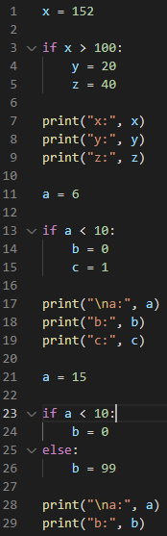
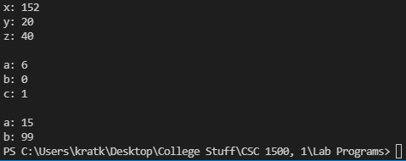

Question Six
Write a function that takes as input an English sentence (a string) and prints the total number

of vowels and the total number of consonants in the sentence. The function returns nothing.

Note that the sentence could have special characters like dots, dashes, and so on.

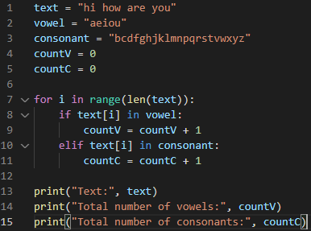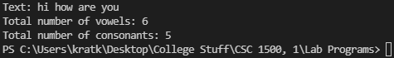

Question Seven
The Fibonacci sequence is: 1, 1, 2, 3, 5, 8, 13 … You can see that the first and second numbers

are both 1. Thereafter, each number is the sum of the previous two numbers.

(a) Write a function to print the first N numbers of Fibonacci sequence.
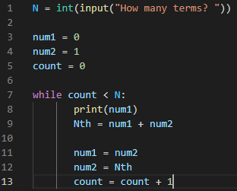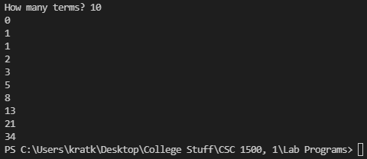

(b) Write a function to print the Nth number of the sequence.

